“Mini Linux Shell with Background Job Management”
A Project Report Submitted in the partial fulfillment of the requirements for the award of the degree of
BACHELOR OF TECHNOLOGY
In
DEPARTMENT OF COMPUTER SCIENCE ENGINEERING
By
K. KEATHANA VIKASHINI 2520090236
LAHARI NAMALA 2520090226
PALVADI BHAGYASRI 2520080024
POOJITHA CHALLA 2520090234
Team No. 20 | Section S13
Under the Esteemed Guidance of
Dr. [Guide Name]
Assistant Professor
Department of Computer Science and Engineering



K L (Deemed to be) University
DEPARTMENT OF COMPUTER SCIENCE ENGINEERING
&
DEPARTMENT OF COMPUTER SCIENCE AND INFORMATION TECHNOLOGY

Mini Project Report
Course: OPERATING SYSTEMS AND SYSTEMS PROGRAMMING (25CS2104E)
Y25 B.Tech. II Year Term-IV Hackathon | 17 October 2026

Declaration
The Project Report entitled “Mini Linux Shell with Background Job Management” is a record of Bonafide work of K. KEATHANA VIKASHINI - 2520090236, LAHARI NAMALA - 2520090226, PALVADI BHAGYASRI - 2520080024, POOJITHA CHALLA - 2520090234 submitted in partial fulfillment for the award of B. Tech in Computer Science and Engineering (or) Computer Science and Information Technology to the K L University. The results embodied in this report have not been copied from any other departments/University/Institute.
K. KEATHANA VIKASHINI 2520090236
LAHARI NAMALA 2520090226
PALVADI BHAGYASRI 2520080024
POOJITHA CHALLA 2520090234

K L (Deemed to be University)
DEPARTMENT OF COMPUTER SCIENCE ENGINEERING
CERTIFICATE
This is to certify that the mini project based report entitled “Mini Linux Shell with Background Job Management” is a bonafide work done and submitted by K. KEATHANA VIKASHINI - 2520090236, LAHARI NAMALA - 2520090226, PALVADI BHAGYASRI - 2520080024, POOJITHA CHALLA - 2520090234 in partial fulfillment of the requirements for the award of the degree of BACHELOR OF TECHNOLOGY in Department of Computer Science Engineering, K L (Deemed to be University), during the academic year 2026-2027.
Signature of the Guide
Signature of the Course Coordinator Signature of the HOD

ACKNOWLEDGEMENT
The success of this project would not have been possible without the timely help and guidance rendered by many people. We wish to express our sincere thanks to all those who assisted us in one way or the other in completing our project.
Our greatest appreciation goes to our Course Coordinator and our guide, Dr. [Guide Name], Department of Computer Science and Engineering, whose tremendous support, encouragement and guidance cannot be expressed in words.
We express our gratitude to Dr. P. Venkateshwara Rao (CSE), Head of the Department of Computer Science Engineering, for providing us with adequate facilities, ways and means by which we were able to complete this project-based lab.
We thank all the members of the teaching and non-teaching staff who have assisted us directly or indirectly in the successful completion of this project. Finally, we sincerely thank our parents, friends and classmates for their kind help and cooperation during our work.
K. KEATHANA VIKASHINI 2520090236
LAHARI NAMALA 2520090226
PALVADI BHAGYASRI 2520080024
POOJITHA CHALLA 2520090234

Abstract
Every Linux user depends on a shell, yet the mechanisms that let it run several programs at once, pause them, resume them and end them are normally hidden behind a prompt. This project, Mini Linux Shell with Background Job Management, opens those mechanisms up. It is a command interpreter written in C11 that executes commands, runs selected programs in the background, lists them with their real process identifiers and states, and terminates, stops or resumes them on request.
The shell is built directly on POSIX process-management interfaces. A command is parsed (including quoting, escaping and a trailing ampersand), and an external program is started with fork and execvp inside its own process group. Foreground jobs receive ownership of the terminal through tcsetpgrp; background jobs leave the prompt free. A fixed table of 32 job records tracks each job’s ID, PID, state and exit status. Built-ins jobs, fg, bg, kill, cd, pwd, help and exit provide visibility and control. Child termination is detected through SIGCHLD and collected with waitpid, so no zombie processes remain, and signal handlers only set flags and write to a self-pipe, keeping all unsafe work in the main event loop.
An optional desktop interface in Python/Tkinter connects to the C shell through a pseudo-terminal and receives live job-table snapshots over a private Unix datagram socket, so the interface displays genuine process state rather than simulated results. Ten process-level integration tests using real child processes pass, and the C source compiles without warnings under strict GCC flags. The project turns abstract operating-system topics such as process creation, process groups, signals, terminal ownership and zombie prevention into something a learner can see and control.

Index
S. No. | Chapter | Topics / Subtopics | Page No.
 | Acknowledgement |  | i
 | Abstract |  | ii
1 | Introduction |  | 1–3
 |  | 1.1 Background of the Project | 1
 |  | 1.2 Problem Statement | 1
 |  | 1.3 Scope of the Project | 1
 |  | 1.4 Objectives of the Project | 2
 |  | 1.5 Importance of the Application | 2
 |  | 1.6 Target Users / Audience | 3
2 | OS Concepts and Background Study |  | 4–6
 |  | 2.1 Operating System Concepts Related to the Project | 4
 |  | 2.2 Existing Methods / Algorithms | 5
 |  | 2.3 Proposed Approach | 5
 |  | 2.4 Advantages of the Proposed Approach | 6
3 | System Requirements |  | 7–8
 |  | 3.1 Hardware Requirements | 7
 |  | 3.2 Software Requirements | 7
 |  | 3.3 Operating System Environment – Ubuntu / WSL | 7
 |  | 3.4 Development Tools and Compilers | 8
4 | Technology and Tools Used |  | 9–10
 |  | 4.1 C / C++ Programming | 9
 |  | 4.2 GCC Compiler | 9
 |  | 4.3 Linux System Calls | 9
 |  | 4.4 POSIX Threads / Synchronization | 10
 |  | 4.5 Linux Commands and Utilities | 10
 |  | 4.6 Other Tools / Libraries Used | 10
5 | System Architecture and Design |  | 11–15
 |  | 5.1 Overall System Architecture | 11
 |  | 5.2 System Workflow | 11
 |  | 5.3 Flowchart / Data Flow | 12
 |  | 5.4 Module Description | 13
 |  | 5.5 Input and Output Design | 14
6 | Implementation |  | 16–23
 |  | 6.1 Module-wise Implementation | 16
 |  | 6.2 Algorithm / Pseudocode | 19
 |  | 6.3 Core C / C++ Implementation | 19
 |  | 6.4 Linux System Calls / APIs Used | 21
 |  | 6.5 Process / Thread Implementation | 21
 |  | 6.6 IPC / Synchronization Implementation | 22
 |  | 6.7 Memory Management Implementation | 22
 |  | 6.8 Optional User Interface Implementation | 22
7 | Execution and Demonstration |  | 24–27
 |  | 7.1 Compilation in Ubuntu | 24
 |  | 7.2 Execution Commands | 24
 |  | 7.3 Sample Inputs and Outputs | 25
 |  | 7.4 Screenshots of Execution | 26
 |  | 7.5 Demonstration of OS Concepts | 26
8 | Conclusion |  | 28–29
 |  | 8.1 Summary of the Project | 28
 |  | 8.2 Objectives Achieved | 28
 |  | 8.3 Results Achieved | 28
 |  | 8.4 Skills and Learning Outcomes | 29
 |  | 8.5 Limitations and Future Scope | 29
9 | References |  | 30
 |  | 9.1 Books | 30
 |  | 9.2 Research Papers | 30
 |  | 9.3 Linux / GNU Documentation | 30
 |  | 9.4 Online Resources | 30

CHAPTER 1: INTRODUCTION

1.1 Background of the Project
A shell is the program through which most people talk to a Linux system. It reads a line of text, decides which program the user wants, asks the operating system to run it and reports the result. Although the idea looks simple, a useful shell has to solve several operating-system problems at once: it must create processes, replace their program images, wait for them, let more than one of them live at the same time, share a single terminal between them, and react correctly when they stop, finish or are killed.
Early UNIX systems ran one program at a time from the prompt. Job control, introduced later in the BSD and System V families and standardised by POSIX, let a user run a command in the background, suspend a running command with Ctrl+Z, and bring it back with fg or bg. These features rest on a small set of kernel facilities: process groups, controlling terminals, signals and the wait family of calls. Because they are normally hidden inside shells such as Bash, students often learn the vocabulary without ever seeing the machinery work.
This project builds a small shell from first principles in C so that each of those facilities is used directly and can be observed. The shell is intentionally limited to one external program per job, which keeps the code short enough to read and explain, while the process-management behaviour (foreground and background execution, stopping, resuming, terminating and reaping) is real Linux behaviour.

1.2 Problem Statement
Problem 7 – Mini Linux Shell with Background Job Management: develop a shell that supports command execution, background jobs, job listing and process termination.
The system must execute user commands while allowing selected jobs to continue independently of the prompt, and must give the user meaningful control and visibility over those jobs. Visibility means the user can see which jobs exist, their process IDs and their states. Control means the user can bring a job to the foreground, stop it, resume it, or terminate it.

1.3 Scope of the Project

Within scope
- Reading and parsing a command line with whitespace separation, single and double quotes, backslash escapes and an optional trailing &.
- Executing external programs through fork and execvp.
- Foreground execution with correct terminal ownership, and background execution that returns the prompt immediately.
- A job table that assigns an ID to every launched program and records its PID, state, mode and exit status.
- Built-in commands: jobs, fg, bg, kill, cd, pwd, help and exit.
- Signal handling for Ctrl+C, Ctrl+Z, SIGCHLD and shutdown, with prompt reaping of finished children.
- An optional desktop interface that shows real job state from the C shell.

Outside scope
- Pipelines, input/output redirection, command chaining with ;, wildcard expansion, variable substitution and shell scripts.
- Full terminal emulation in the desktop view (full-screen programs such as vim are not supported by the UI).
- Jobs made up of several processes, and daemonising programs that deliberately escape their process group.
- CPU-scheduling algorithms; scheduling is left to the Linux kernel.

1.4 Objectives of the Project
- Read and parse command lines and arguments.
- Execute external programs through fork and exec.
- Support foreground and background execution.
- Maintain an identifiable job table.
- Implement jobs, fg, bg and job-specific signal delivery.
- Protect the shell from terminal interrupts intended for child jobs.
- Reap children promptly and clean up tracked jobs at normal shutdown.
- Provide a desktop interface suitable for a live demonstration.

1.5 Importance of the Application
The shell is the most visible example of an operating system at work. Building one forces the developer to understand how a process is born, how it is identified, how it receives signals and how the kernel tells the parent when it has finished. Mistakes show up immediately: forget to reap a child and a zombie remains in the process table; let the shell share the terminal with a child and the keyboard input goes to the wrong program; handle a signal unsafely and the shell occasionally deadlocks.
The project therefore has both educational and practical value. It gives a working reference for the standard job-control sequence (fork, setpgid, tcsetpgrp, exec, waitpid), and it demonstrates good engineering habits for signals, such as keeping handlers tiny and doing the real work in the main loop. The live interface makes these ideas visible during a demonstration or a viva.

1.6 Target Users / Audience
- Students of operating systems and systems programming who want to see process control working.
- Instructors who need a compact, readable example for lectures and lab demonstrations.
- Developers who want a reference implementation of POSIX job control in about 500 lines of C.
- Evaluators and reviewers who need to verify process states through real PIDs rather than simulated output.

CHAPTER 2: OS CONCEPTS AND BACKGROUND STUDY

2.1 Operating System Concepts Related to the Project
The project touches most of the process-management portion of an operating-systems course. The concepts and the place where each is used in the shell are summarised in Table 2.1.
Concept | How it appears in the project
Program and process | A program is code on disk; a process is a running instance with an ID, state and resources. Each command typed in the shell becomes a new process.
Parent / child relationship | The shell calls fork; the child calls execvp to become the requested program. The shell is the parent and must collect the child’s exit status.
Process identity | Each child’s PID is also the ID of its own process group, so signals can address the whole job with kill(-pid, sig).
Foreground execution | The terminal belongs to the job’s process group while the shell waits for it.
Background execution | The shell keeps terminal ownership and accepts new input while the job runs.
Concurrency | The kernel schedules the shell and its children independently; the shell never busy-waits.
Signals | SIGINT, SIGTSTP, SIGCHLD, SIGTERM, SIGSTOP, SIGCONT, SIGHUP and SIGKILL are all used.
Synchronisation | The parent waits for foreground completion or stopping; a launch gate pipe makes the child wait until the terminal is handed over.
Zombie prevention | waitpid consumes each child’s termination status so no zombie remains.
File-system state | cd is a built-in because it must change the parent shell’s working directory.
Inter-process communication | A pseudo-terminal for text I/O, a self-pipe for wake-ups and a Unix datagram socket for UI status.
Table 2.1 Operating-system concepts and their use in the project

Process creation: fork and exec
fork duplicates the calling process. It returns zero in the child and the child’s PID in the parent. The child then calls execvp, which replaces its program image with the requested program while keeping the same PID. If execvp returns, the program could not be started, and the child reports the error and exits with code 127 (not found) or 126 (not executable).

Process groups and the controlling terminal
A process group is a collection of related processes that can be addressed together for signals and terminal access. A terminal has one foreground process group at a time; only that group may read from the terminal freely. The shell places every job in its own group and uses tcsetpgrp to make the chosen group the foreground group. This is what makes Ctrl+C reach the running job instead of the shell.

Signals
A signal is an asynchronous notification delivered by the kernel. Ctrl+C generates SIGINT, Ctrl+Z generates SIGTSTP, and a finished child generates SIGCHLD in its parent. SIGSTOP and SIGKILL cannot be caught or ignored. Because a handler can interrupt the program at any point, only async-signal-safe actions may be taken inside it.

Zombie processes
When a child terminates, the kernel keeps its exit status until the parent collects it. A terminated child whose status has not been collected is a zombie. waitpid collects the status and lets the kernel free the entry.

2.2 Existing Methods / Algorithms
Production shells such as Bash, Zsh and Dash implement full POSIX job control. Their approach to job management follows the same basic algorithm described in the GNU C Library manual: put each job in its own process group, hand the terminal to the foreground group, wait for it with waitpid using the WUNTRACED flag so stops are noticed, and take the terminal back afterwards.
For detecting finished background jobs there are two common techniques:
- Reaping inside the SIGCHLD handler. The handler calls waitpid in a loop. This is simple but means job-table updates and output happen asynchronously, with the risk of unsafe calls and data races with the main loop.
- Polling before each prompt. The shell calls waitpid(WNOHANG) only when it is about to print a prompt. This is safe but delays notification until the user presses Enter.
Large shells also keep a job as a list of several processes (for pipelines), use dynamic data structures, and support redirection and scripting. These features go beyond what is needed to demonstrate background job management.

2.3 Proposed Approach
The proposed shell combines the strengths of both reaping techniques with an event-loop design:
- The main loop blocks in poll on two descriptors: standard input and a non-blocking self-pipe read end.
- The SIGCHLD, SIGINT, SIGTERM and SIGHUP handlers only set a sig_atomic_t flag and write one byte to the self-pipe. They never allocate memory, print or touch the job table.
- When the pipe becomes readable the loop drains it and calls waitpid(-1, WNOHANG | WUNTRACED | WCONTINUED) in a loop, updates the job table and prints a completion notice immediately, without waiting for the user to press Enter.
- Each launched program is a single command in its own process group. The child waits on a launch gate pipe until the parent has transferred terminal ownership, so a new foreground program can never read the keyboard too early.
- Input is read one byte at a time so the shell never consumes characters meant for a foreground child such as cat.
- A fixed 32-slot job table is used. Finished slots are reused; active jobs are never evicted.

2.4 Advantages of the Proposed Approach
- Safe signal handling: only flags and a one-byte write occur in handlers, avoiding unsafe library calls.
- Immediate notification: finished background jobs are reported without user input.
- No zombies: every child is reaped in the event loop, and all tracked jobs are cleaned up at exit.
- Correct terminal ownership: the launch gate and tcsetpgrp ensure keyboard input goes only to the foreground job.
- Predictable memory use: static arrays and stack buffers are used; there is no dynamic allocation to leak.
- Easy to explain: the whole core is a single C file of about 535 lines, suitable for study and demonstration.

CHAPTER 3: SYSTEM REQUIREMENTS

3.1 Hardware Requirements
The shell is a small user-space program and has very modest requirements. Table 3.1 lists a practical configuration; any modern laptop or college lab machine meets it.
Component | Requirement
Processor | Any 64-bit x86 or ARM processor (dual-core or better recommended)
Memory | 2 GB RAM minimum; 4 GB recommended when running the desktop interface
Storage | About 200 MB free for the toolchain, source and build output
Display | Any display that runs a graphical Linux session (needed only for the desktop UI)
Input | Keyboard and mouse
Table 3.1 Hardware requirements

3.2 Software Requirements
Software | Purpose
Ubuntu Linux (native, or WSL on Windows) | Target operating system with POSIX job-control support
GCC (build-essential) | Compiles the C11 shell with warnings enabled
GNU make | Builds, runs and tests with one command
Python 3.10 or later | Desktop interface and integration test suite
python3-tk | Tkinter graphical toolkit for the desktop interface
Text editor / VS Code | Source editing
Table 3.2 Software requirements
No Python packages, web server, database or internet connection are required after the system packages are installed.

3.3 Operating System Environment – Ubuntu / WSL
The C program uses Linux and POSIX interfaces (fork, setpgid, tcsetpgrp, waitpid, pseudo-terminals), so it must run on Linux. On a college Ubuntu desktop nothing more is needed. On Windows, Ubuntu is installed inside the Windows Subsystem for Linux with wsl --install -d Ubuntu; the command-line shell then works in any WSL session, and the desktop interface works when WSLg (or another Linux display) is available. Native Windows compilers and Windows CMD cannot be used.
Setup on Ubuntu:
sudo apt update
sudo apt install -y build-essential python3 python3-tk

3.4 Development Tools and Compilers
- GCC with -std=c11 -Wall -Wextra -Wpedantic -O2; the code compiles with no warnings.
- make with targets all, run, ui, test and clean.
- Python unittest for the process-level integration tests.
- Git for version control (the project ships a .gitignore).
- Xvfb (optional) to run the interface smoke test on a machine without a display.

CHAPTER 4: TECHNOLOGY AND TOOLS USED

4.1 C / C++ Programming
The shell core is written in C11. C is the natural language for systems programming on Linux because it exposes the POSIX system-call interface directly, has no runtime that hides process behaviour, and produces a small native executable. The program defines the feature-test macro _POSIX_C_SOURCE 200809L so the POSIX 2008 declarations are available under strict C11 mode. The core uses fixed-size arrays, static state, sigaction for handlers and sig_atomic_t flags shared with those handlers. C++ is not used.

4.2 GCC Compiler
GCC compiles mini_shell.c with strict diagnostics so that unsafe constructs are caught at build time:
gcc -std=c11 -Wall -Wextra -Wpedantic -O2 mini_shell.c -o mini_shell
Flag | Meaning
-std=c11 | Compile as ISO C11
-Wall -Wextra -Wpedantic | Enable common, extra and standard-conformance warnings
-O2 | Optimise for speed without increasing code size excessively
Table 4.1 Compiler flags

4.3 Linux System Calls
System call / API | Role in the shell
fork() | Create the child process for each external command
execvp() | Replace the child with the requested program, searching PATH
waitpid() | Collect child exit/stop/continue status (WNOHANG, WUNTRACED, WCONTINUED)
setpgid(), getpgrp() | Place each job in its own process group
tcsetpgrp(), tcgetpgrp() | Give the terminal to a job or back to the shell
tcgetattr(), tcsetattr() | Save and restore terminal modes for stopped/resumed jobs
kill() | Send signals to a job’s process group with a negative PID
sigaction() | Install signal handlers and set SIG_IGN / SIG_DFL
pipe(), poll(), read(), write() | Self-pipe wake-up, launch gate and the event loop
chdir(), getcwd() | Implement cd and pwd
send() | Publish job-table snapshots on a Unix datagram socket
nanosleep() | Short bounded pauses during shutdown
Table 4.2 Linux system calls used

4.4 POSIX Threads / Synchronization
The shell is deliberately single-threaded; POSIX threads are not used. Concurrency comes from separate processes, which the kernel schedules independently, so there is no shared-memory data race inside the shell. Synchronisation is nevertheless present and is done with process-level mechanisms:
- `waitpid` synchronises the parent with child completion or stopping.
- Launch gate pipe blocks a new child on a read until the parent has transferred terminal ownership, then releases it by closing the write end.
- Self-pipe and `poll` turn asynchronous signals into ordinary events handled in sequence by the main loop.
- `sig_atomic_t` flags are the only data shared between handlers and the main loop.

4.5 Linux Commands and Utilities
Linux utilities are used both as test programs inside the shell and as development tools outside it.
Command | Use
sleep N | A simple long-running program for background, stop, resume and terminate demonstrations
echo, ls, pwd, cat | Short foreground programs; cat also tests terminal input and SIGTTIN
make | Build and test automation
ps, /proc | Verify that terminated children disappear from the process table
xvfb-run | Run the desktop smoke test without a display
Table 4.3 Linux commands and utilities

4.6 Other Tools / Libraries Used
- Python 3 standard library only: tkinter / ttk for the interface, pty, os, fcntl, termios, socket, codecs, struct and json for the transport.
- Python `unittest` for the integration tests, which drive the shell through a real controlling pseudo-terminal.
- Unix datagram socket pair to carry JSON status snapshots from the C shell to the interface.

CHAPTER 5: SYSTEM ARCHITECTURE AND DESIGN

5.1 Overall System Architecture
The system has three layers, shown in Figure 5.1. The desktop interface provides a command entry, an output view and a jobs panel. The PTY transport gives the C shell a real controlling terminal, so job control behaves exactly as it does in a normal terminal. The C core owns parsing, job records, process creation, signal policy and cleanup. The Linux kernel enforces process-group terminal access and schedules all runnable processes.
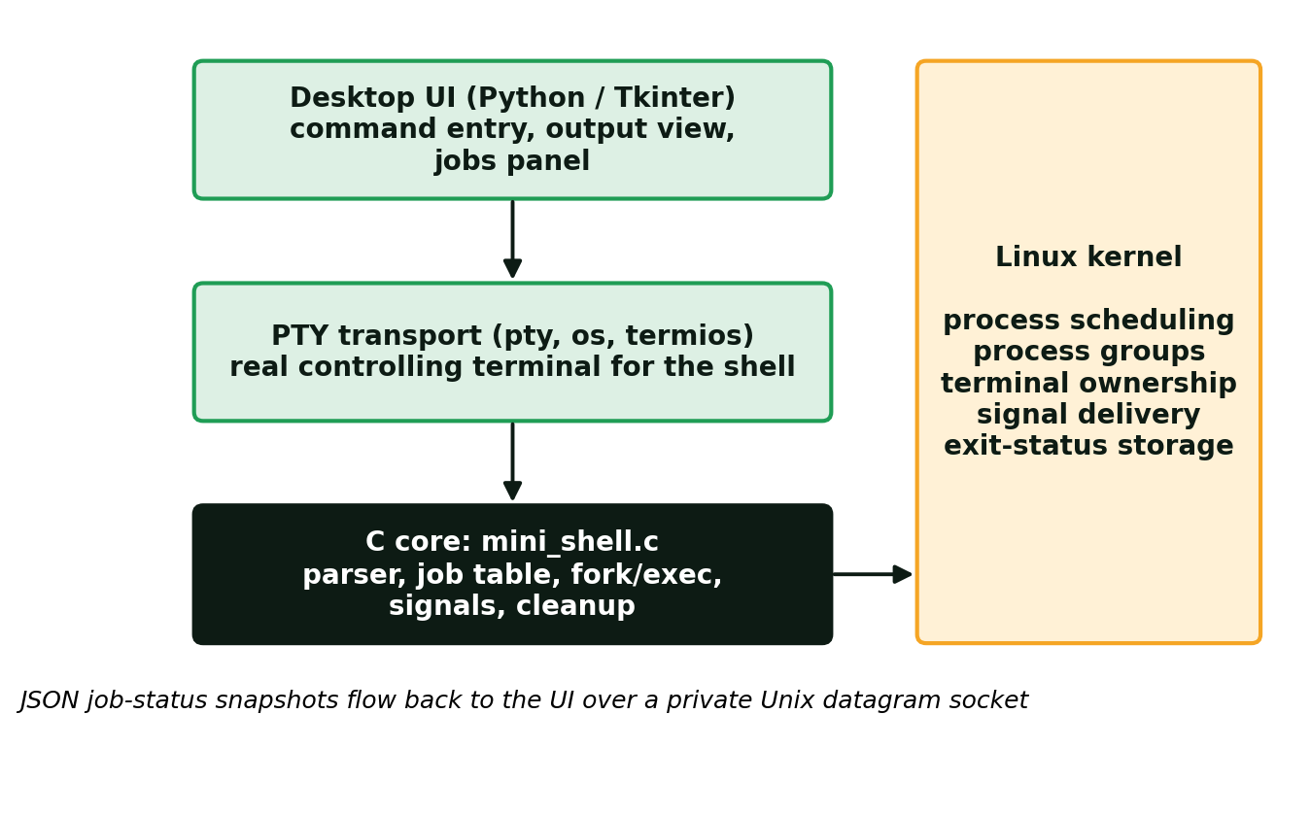
Figure 5.1 Overall system architecture
The desktop status channel is private and local. It receives snapshots of the C job table; commands are never executed by Python’s shell or by a network service. The C program also runs on its own in an ordinary terminal (./mini_shell) without any Python component.

5.2 System Workflow
The execution algorithm followed by the shell for every command is:
- Initialise the process group, terminal settings, signal handlers and the self-pipe.
- Wait for command input or a child-state notification using poll.
- Read one command line without prefetching input intended for children.
- Parse quoting, escaping and an optional final ampersand.
- Execute built-ins in the parent when applicable.
- Otherwise allocate a job-table slot and fork a child for the external command.
- Establish the child’s process group in both parent and child.
- Restore default signal dispositions in the child.
- For a foreground job, transfer terminal ownership before releasing the child.
- The child executes the requested program using execvp.
- For a background job, return immediately to the command prompt.
- Reap state changes with waitpid and publish the updated state to the UI.
- Restore shell terminal ownership when the foreground job stops or exits.
- Repeat until exit or a shutdown signal is received.

5.3 Flowchart / Data Flow
Figure 5.2 shows the decision flow for a single command line.
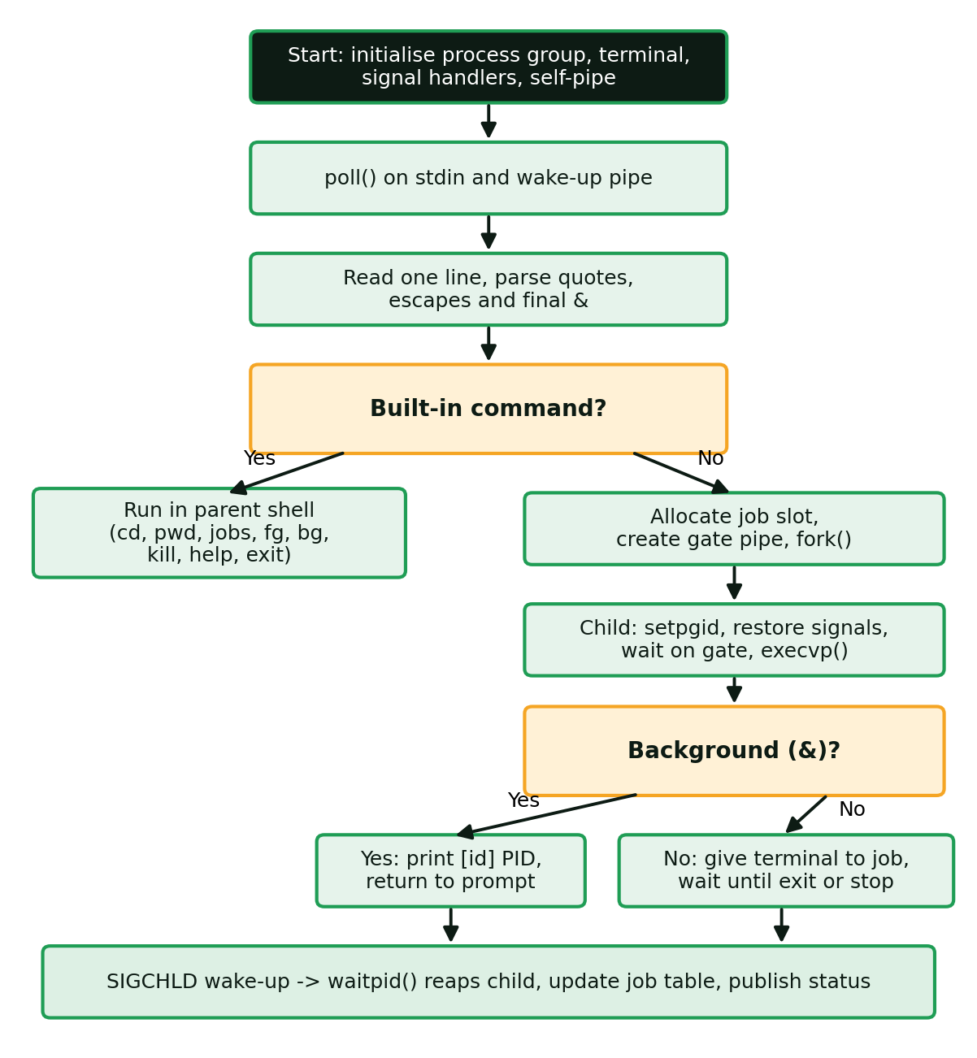
Figure 5.2 Command execution flowchart
Each job moves through three states during its life (Figure 5.3). A job starts as Running. Ctrl+Z or SIGSTOP moves it to Stopped; bg or fg sends SIGCONT and returns it to Running. When the program exits or is terminated by a signal, waitpid reports it and the job becomes Done, storing the exit status (128 plus the signal number for signal deaths).
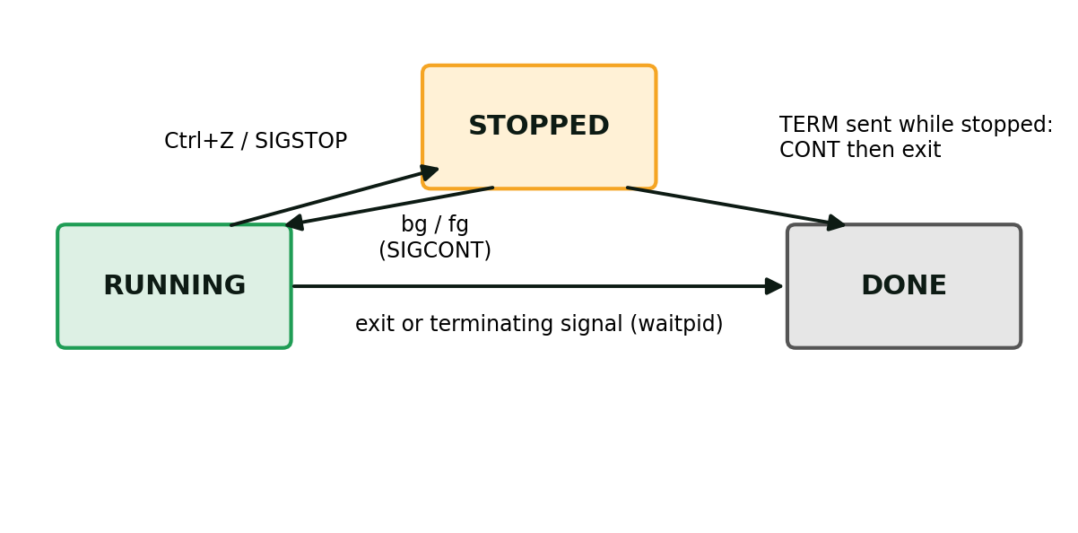
Figure 5.3 Job state transitions

Data flow
- Keyboard → UI → PTY → shell: typed text and control characters (Ctrl+C = 0x03, Ctrl+Z = 0x1A, Ctrl+D = 0x04) travel through the pseudo-terminal master to the shell’s terminal.
- Shell → PTY → UI: program and shell output returns the same way and is shown in the output view.
- Shell → UI (status): after each state change the shell sends a JSON job-table snapshot on a Unix datagram socket; the UI uses it to draw the jobs panel.

5.4 Module Description
Module | File | Responsibility
Parser | mini_shell.c parse() | Splits a line into arguments, handles quotes/escapes, accepts only a final &, rejects | < > ;
Job table | mini_shell.c jobs[32] | Stores ID, PID, state, mode, exit status, command text and saved terminal modes
Built-ins | mini_shell.c builtin() | help, jobs, fg, bg, kill, cd, pwd, exit executed in the parent
Launcher | mini_shell.c launch() | Allocates a slot, forks, sets the process group, execs the program
Foreground wait | mini_shell.c wait_foreground() | Transfers the terminal, waits for exit or stop, restores the shell terminal
Reaper | mini_shell.c reap_children() | Calls waitpid, updates states, prints completion notices
Signal layer | mini_shell.c on_signal() | Sets flags and writes a wake-up byte to the self-pipe
Status publisher | mini_shell.c publish_status() | Sends a JSON snapshot of the job table to the UI
Cleanup | mini_shell.c cleanup() | Sends SIGHUP, then SIGKILL if needed, and reaps all tracked jobs at exit
PTY transport | ui_backend.py | Starts the shell in a pseudo-terminal, passes bytes in and out, reads status packets
Desktop UI | gui.py | Tkinter window: entry, output, jobs panel, control buttons, history
Tests | tests/test_shell.py | Ten integration tests with real processes in a controlling PTY
Table 5.1 Module description

5.5 Input and Output Design

Input
A command is one line of text. The accepted grammar is: command [arguments] [&]. Words are separated by whitespace; single quotes preserve text literally; double quotes allow backslash escapes for \, ", $, backtick and newline; a backslash escapes the next character outside single quotes. A single & is allowed only as the last token. The pipe, redirection and chaining characters | < > ; are rejected with a clear message. Lines up to 4095 bytes and up to 127 arguments are accepted.
Input | Meaning
sleep 30 & | Run sleep in the background
jobs | List tracked jobs
fg %ID / bg %ID | Bring a job to the foreground / resume a stopped job in the background
kill [-SIGNAL] %ID | Signal a tracked job (TERM default; INT, KILL or 9, STOP, CONT)
cd [dir], pwd, help, exit | Built-in utilities
Ctrl+C / Ctrl+Z / Ctrl+D | Interrupt / stop foreground job / end input (exit at an empty prompt)
Table 5.2 Input commands

Output
- The prompt mini-shell> is printed whenever the shell is ready.
- Launching a background job prints [ID] PID.
- A finished or killed background job prints [ID] Done (PID n, status s) command automatically.
- jobs prints a table with the columns JOB, PID, STATE and COMMAND.
- Errors are reported on standard error and the shell keeps running (for example not_a_command: No such file or directory).
- After each state change the shell sends a JSON status snapshot to the UI, in the format shown in Listing 5.1.
{"shell_pid": 4121, "foreground": 0, "cwd": "/home/user/mini-linux-shell",
"jobs": [{"id": 1, "pid": 4130, "state": "Running", "background": true,
"result": 0, "command": "sleep 30 &"}]}
Listing 5.1 Status snapshot sent to the desktop interface (example values)

CHAPTER 6: IMPLEMENTATION

6.1 Module-wise Implementation

Data structure: the job table
The job table is a fixed array of 32 records. A new external command takes the first empty slot; if none is empty, the oldest finished slot is reused. Active (running or stopped) jobs are never evicted, and a full table gives a clear error message instead of overwriting a job.
#define MAX_JOBS 32
#define MAX_LINE 4096
#define MAX_ARGS 128

typedef enum { EMPTY, RUNNING, STOPPED, DONE } State;
typedef struct {
int id;
pid_t pid; /* One external command per process group. */
State state;
bool background;
int result;
bool has_modes;
struct termios modes; /* terminal modes saved when a job is stopped */
char command[MAX_LINE];
} Job;

static Job jobs[MAX_JOBS];
Listing 6.1 Job record and table

Signal layer
The handler does the smallest possible amount of work: it sets a flag and writes one byte to the self-pipe so that poll wakes up. All real work then happens in the ordinary event loop.
static void on_signal(int sig) {
int saved = errno;
if (sig == SIGTERM || sig == SIGHUP) shutting_down = 1;
if (sig == SIGINT) interrupted = 1;
if (wake_pipe[1] >= 0) {
char byte = 'x';
ssize_t written = write(wake_pipe[1], &byte, 1);
(void)written; /* a full pipe already wakes poll */
}
errno = saved;
}
Listing 6.2 Async-signal-safe handler

Reaper
reap_children collects every pending state change without blocking. It distinguishes stopped, continued and terminated children, records the exit status (or 128 + signal number) and prints a notice for finished background jobs.
static bool reap_children(void) {
int status; pid_t pid;
bool changed = false, notified = false;
while ((pid = waitpid(-1, &status,
WNOHANG | WUNTRACED | WCONTINUED)) > 0) {
for (int i = 0; i < MAX_JOBS; ++i) {
Job *j = &jobs[i];
if (j->state == EMPTY || j->pid != pid) continue;
if (WIFSTOPPED(status)) {
j->state = STOPPED; j->result = WSTOPSIG(status);
} else if (WIFCONTINUED(status)) {
j->state = RUNNING;
} else {
j->state = DONE;
j->result = WIFEXITED(status) ? WEXITSTATUS(status)
: 128 + WTERMSIG(status);
}
changed = true;
if (j->background && !WIFCONTINUED(status)) {
printf("\n[%d] %-7s (PID %ld, status %d) %s\n", j->id,
state_name(j->state), (long)j->pid,
j->result, j->command);
notified = true;
}
break;
}
}
if (changed) publish_status();
return notified;
}
Listing 6.3 Child reaping

Launcher
launch is the heart of the shell. It follows the standard job-control sequence. A pipe called the *gate* keeps the child waiting until the parent has finished setting up the process group and terminal.
static void launch(int argc, char **argv, bool background,
const char *line) {
/* ... pick a free job slot, create gate[2] pipe ... */
pid_t pid = fork();
if (pid == 0) { /* child */
close(gate[1]);
if (setpgid(0, 0) < 0) _exit(126); /* own process group */
int signals[] = {SIGINT, SIGQUIT, SIGTSTP, SIGTTIN, SIGTTOU,
SIGCHLD, SIGTERM, SIGHUP, SIGPIPE};
for (size_t k = 0; k < sizeof(signals)/sizeof(signals[0]); ++k)
set_handler(signals[k], SIG_DFL);
close(wake_pipe[0]); close(wake_pipe[1]);
char token; /* wait at the gate */
while (read(gate[0], &token, 1) < 0 && errno == EINTR) {}
close(gate[0]);
execvp(argv[0], argv);
fprintf(stderr, "%s: %s\n", argv[0], strerror(errno));
_exit(errno == ENOENT ? 127 : 126);
}
close(gate[0]); /* parent */
setpgid(pid, pid); /* avoid a race with the child */
slot->id = next_id++; slot->pid = pid; slot->state = RUNNING;
slot->background = background;
if (background) {
close(gate[1]);
printf("[%d] %ld\n", slot->id, (long)pid);
publish_status();
} else wait_foreground(slot, false, gate[1]);
}
Listing 6.4 Process creation (abridged)

Foreground wait
static void wait_foreground(Job *j, bool resume, int release_fd) {
j->background = false;
foreground_pgid = j->pid;
give_terminal(j->pid); /* tcsetpgrp(job group) */
if (interactive && resume && j->has_modes)
tcsetattr(STDIN_FILENO, TCSADRAIN, &j->modes);
if (resume) { kill(-j->pid, SIGCONT); j->state = RUNNING; }
if (release_fd >= 0) close(release_fd); /* open the launch gate */
publish_status();
while (j->state == RUNNING && !shutting_down) {
reap_children();
if (j->state != RUNNING) break;
struct pollfd pfd = {wake_pipe[0], POLLIN, 0};
poll(&pfd, 1, -1);
drain_wakeup();
}
if (interactive && j->state == STOPPED)
j->has_modes = tcgetattr(STDIN_FILENO, &j->modes) == 0;
give_terminal(shell_pgid); /* shell takes the terminal back */
tcsetattr(STDIN_FILENO, TCSADRAIN, &shell_modes);
foreground_pgid = 0;
if (j->state == STOPPED) {
j->background = true;
printf("[%d] Stopped %s\n", j->id, j->command);
}
publish_status();
}
Listing 6.5 Foreground execution (abridged)

6.2 Algorithm / Pseudocode

Main event loop
initialise(): process group, terminal modes, self-pipe, handlers
print banner and prompt
while not shutting_down:
poll(stdin, wake_pipe)
if wake_pipe readable:
drain wake_pipe
notified = reap_children() # SIGCHLD path
if interrupted: discard partial line
if notified: print prompt
if stdin readable:
read ONE byte c
if EOF: execute pending line; shutting_down = true
else if c == '\n': execute(line); print prompt
else append c to line (set overflow flag if too long)
cleanup()
Listing 6.6 Pseudocode for the main loop

Command execution
execute(line):
argc = parse(line, argv, &background)
if argc <= 0: return # syntax error or empty
reap_children()
if is_builtin(argv[0]):
run_builtin() # in the parent shell
else:
launch(argv, background, line)
Listing 6.7 Pseudocode for command execution

Shutdown cleanup
cleanup():
send SIGHUP then SIGCONT to every running/stopped job group
repeat up to 10 times (30 ms each):
if no active jobs: break
reap_children()
send SIGKILL to any job still active
waitpid(-1) until no children remain
mark remaining jobs Done (status 137)
restore terminal ownership and modes
Listing 6.8 Pseudocode for cleanup

6.3 Core C / C++ Implementation

Command parser
The parser is a small state machine over characters. It recognises quotes and escapes, rejects unsupported operators and treats an ampersand as the background marker only when it is the last token.
static int parse(const char *line, char *storage,
char **argv, bool *background) {
const char *p = line; char *out = storage; int argc = 0;
*background = false;
while (*p) {
while (isspace((unsigned char)*p)) ++p;
if (!*p) break;
if (*p == '&') {
++p; while (isspace((unsigned char)*p)) ++p;
if (*p || !argc) { fprintf(stderr,
"Syntax: & must follow a command at the end.\n"); return -1; }
*background = true; break;
}
argv[argc++] = out;
char quote = 0;
while (*p) {
char c = *p;
if (!quote && (isspace((unsigned char)c) || c == '&')) break;
if (!quote && strchr("|<>;", c)) {
fprintf(stderr, "Pipes, redirection and command chaining
are not supported.\n"); return -1; }
++p;
if (!quote && (c == '\'' || c == '"')) { quote = c; continue; }
if (quote && c == quote) { quote = 0; continue; }
/* backslash handling omitted here */
*out++ = c;
}
if (quote) { fprintf(stderr, "Unclosed quote.\n"); return -1; }
*out++ = '\0';
}
argv[argc] = NULL; return argc;
}
Listing 6.9 Command parser (abridged)

The kill built-in
kill accepts only IDs of jobs tracked by this shell, never arbitrary system PIDs. The signal is sent to the whole process group with a negative PID. A stopped job that receives SIGTERM is also sent SIGCONT so that it can actually act on the signal and terminate.
int sig = SIGTERM, pos = 1;
if (argc > 1 && argv[1][0] == '-') {
const char *s = argv[1] + 1;
if (!strncmp(s, "SIG", 3)) s += 3;
if (!strcmp(s, "TERM")) sig = SIGTERM;
else if (!strcmp(s, "INT")) sig = SIGINT;
else if (!strcmp(s, "KILL") || !strcmp(s, "9")) sig = SIGKILL;
else if (!strcmp(s, "STOP")) sig = SIGSTOP;
else if (!strcmp(s, "CONT")) sig = SIGCONT;
else { fprintf(stderr, "Unsupported signal.\n"); return true; }
pos = 2;
}
Job *j = job_argument(argv[pos]);
if (j) {
if (kill(-j->pid, sig) < 0) perror("kill");
else if (sig == SIGTERM && j->state == STOPPED)
kill(-j->pid, SIGCONT);
}
Listing 6.10 Job-specific signal delivery

6.4 Linux System Calls / APIs Used
System call | Where used | Purpose
fork | launch() | Create the child process
setpgid | launch() child and parent; main() | Give each job its own process group; make the shell a group leader
execvp | launch() child | Replace the child with the requested program
waitpid | reap_children(), cleanup() | Collect exit, stop and continue status; prevent zombies
tcsetpgrp / tcgetpgrp | give_terminal(), main() | Assign foreground ownership of the terminal
tcgetattr / tcsetattr | wait_foreground(), cleanup() | Save and restore terminal modes across stop/resume
kill (negative PID) | builtin(), signal_active() | Signal an entire job process group
sigaction | set_handler() | Install handlers, SIG_IGN and SIG_DFL
pipe / poll / read / write | main(), launch(), on_signal() | Self-pipe, launch gate, event loop, one-byte input
chdir / getcwd | builtin() | cd and pwd
send (MSG_DONTWAIT) | publish_status() | Non-blocking status telemetry to the UI
nanosleep | cleanup() | Bounded grace period at shutdown
Table 6.1 System calls and where they are used

6.5 Process / Thread Implementation
Each external command is one process created with fork. The child immediately becomes the leader of a new process group (setpgid(0, 0)), so the child’s PID doubles as the job’s process-group ID. The parent repeats the setpgid(pid, pid) call to remove the race between the two processes. Signals are then sent with kill(-pid, sig) so they reach every process in the job, and terminal ownership is assigned with tcsetpgrp(pid).
The shell itself is a single thread running one event loop. It is never blocked waiting for a background job; a foreground job blocks it only inside poll, which still wakes for SIGCHLD and shutdown. The child restores default signal actions for INT, QUIT, TSTP, TTIN, TTOU, CHLD, TERM, HUP and PIPE before exec, so the launched program behaves as in any other shell. A background job that tries to read from the terminal legitimately receives SIGTTIN and stops until it is moved to the foreground.

6.6 IPC / Synchronization Implementation
Mechanism | Between | Purpose
Self-pipe (non-blocking) | Signal handler → main loop | Converts asynchronous signals into a pollable event
Launch gate pipe | Parent → new child | Child cannot exec or read the terminal until the parent finishes ownership transfer
Pseudo-terminal (PTY) | UI ↔ shell | Gives the shell a real controlling terminal; carries text and control characters
Unix datagram socket pair | Shell → UI | One-way JSON job-state snapshots; sent non-blocking so the shell can never stall
waitpid | Child → parent | Reports exit, stop and continue transitions
Table 6.2 IPC and synchronisation mechanisms
Every descriptor that must not leak into children is marked close-on-exec, and the child explicitly closes the wake-up pipe and the status descriptor before exec, so launched programs never inherit the shell’s internal channels.

6.7 Memory Management Implementation
The shell uses no dynamic allocation. The job table is a static array of 32 records; the input line (4096 bytes), argument vector (128 pointers), parse storage and the 64 KB status buffer are fixed arrays on the stack or in static storage. Consequences:
- There are no memory leaks and no malloc/free calls in signal-related paths.
- Every write to a buffer is bounded: snprintf and a custom append function stop at capacity, and oversized input lines are rejected with a clear message.
- The job table is bounded at 32 entries; when full the shell refuses new jobs instead of overwriting an active one.
- fork gives each child its own copy-on-write address space, and execvp then replaces it entirely with the new program image.

6.8 Optional User Interface Implementation
The optional desktop interface is a Python 3 / Tkinter program split into two files.

ui_backend.py – transport only
ShellSession creates a Unix datagram socket pair and starts the C shell inside a pseudo-terminal using pty.fork(). The write end of the socket is passed to the shell through the MINISHELL_STATUS_FD environment variable. The class exposes send, read_output (bounded to 32 reads per call so the interface stays responsive), read_state (decodes JSON snapshots), resize, check_exit and request_close. It never interprets or runs commands.

gui.py – presentation
- A command entry with Run/Send, history navigation (Up/Down) and control shortcuts: Ctrl+C interrupt, Ctrl+Z stop, Ctrl+D end input, Ctrl+L clear.
- A live output view connected to the shell’s terminal.
- A jobs panel (tree view) that shows real job ID, PID, state and mode from the C job table, plus a current-directory footer and counters.
- Buttons Foreground, Stop ^Z, Resume and Terminate; they issue fg, Ctrl+Z, bg and kill to the C shell and are disabled while a foreground program owns the terminal.
- On window close, the UI asks the shell to clean up its tracked jobs before exiting.
A smoke test (python3 gui.py --smoke-test) opens the window, submits sleep 30 & and pwd, and closes with cleanup. It requires a graphical display; on a headless machine it can be run under Xvfb.

CHAPTER 7: EXECUTION AND DEMONSTRATION

7.1 Compilation in Ubuntu
Install the dependencies once, then build with make:
sudo apt update
sudo apt install -y build-essential python3 python3-tk
make
Without make, the same build is:
gcc -std=c11 -Wall -Wextra -Wpedantic -O2 mini_shell.c -o mini_shell
The build completes with no compiler warnings. The Makefile provides these targets:
Target | Action
make | Compile mini_shell with warnings enabled
make run | Build and open the command-line shell
make ui | Build and open the desktop interface
make test | Run the 10 integration tests
make clean | Remove the compiled binary
Table 7.1 Makefile targets

7.2 Execution Commands
./mini_shell # command-line shell in a normal terminal
python3 gui.py # desktop interface
bash run.sh # build and launch the desktop interface
make test # run the automated checks
python3 gui.py --smoke-test
xvfb-run -a python3 gui.py --smoke-test # headless machine
Commands to try inside the application:
help
pwd
ls
echo "Hello from our mini shell"
sleep 30 &
jobs
fg %N # use the ID shown by jobs
bg %N
kill %N
kill -STOP %N
kill -KILL %N
Every external command receives a new job ID, including foreground commands, so a sleep job may not be %1. Always use the ID printed by the shell.

7.3 Sample Inputs and Outputs
The following transcripts were captured from real runs of the compiled shell in a controlling pseudo-terminal. They are unedited except that the carriage returns added by the terminal have been removed.

Sample 1: built-ins, background job and responsiveness
mini-shell> pwd
/home/claude/proj/mini-linux-shell
mini-shell> echo "Hello from mini shell"
Hello from mini shell
mini-shell> sleep 30 &
[2] 208
mini-shell> echo shell-is-responsive
shell-is-responsive
mini-shell> jobs
JOB PID STATE COMMAND
[2 ] 208 Running sleep 30 &
Output 7.1 Background job leaves the prompt free

Sample 2: automatic completion and error handling
mini-shell> sleep 2 &
[4] 210
mini-shell>
[4] Done (PID 210, status 0) sleep 2 &
mini-shell> not_a_command
not_a_command: No such file or directory
mini-shell> ls | wc
Pipes, redirection and command chaining are not supported.
Output 7.2 Completion notice without user input; errors do not stop the shell

Sample 3: foreground, stop, resume, terminate
mini-shell> sleep 60 &
[1] 230
mini-shell> fg %1
^Z[1] Stopped sleep 60 &
mini-shell> jobs
JOB PID STATE COMMAND
[1 ] 230 Stopped sleep 60 &
mini-shell> bg %1
[1] Running sleep 60 &
mini-shell> kill %1
Signal 15 sent to job [1] (PGID 230).
mini-shell>
[1] Done (PID 230, status 143) sleep 60 &
mini-shell> cd /tmp
mini-shell> pwd
/tmp
mini-shell> exit
Shell closed. Tracked jobs cleaned up.
Output 7.3 Full job life cycle (status 143 = 128 + SIGTERM)

7.4 Screenshots of Execution
Outputs 7.1 to 7.3 above are real terminal captures of the demonstration sessions. For the desktop interface, Table 7.2 lists the screens to capture and paste into the final submission, since a screenshot must be taken on the machine used for the demonstration.
Figure | Screen to capture | What it shows
7.1 | Desktop UI after sleep 30 & and echo shell-is-responsive | Job in Running state; prompt still free
7.2 | Jobs panel with a job selected, after Stop ^Z | State changes to Stopped; shell owns the terminal
7.3 | After Resume and then Terminate | Job returns to Running, then becomes Done (status 143)
7.4 | Output of make test | All 10 tests reported OK
Table 7.2 Screenshots for the desktop demonstration
Result of make test on the development machine:
test_background_job_keeps_shell_responsive ... ok
test_background_terminal_reader_stops_until_foreground ... ok
test_completed_background_job_is_reaped_without_input ... ok
test_ctrl_z_bg_and_resume_foreground ... ok
test_directory_changes_persist_in_parent ... ok
test_errors_do_not_crash_shell ... ok
test_exit_cleans_running_stopped_and_hup_ignoring_jobs ... ok
test_external_command_and_quotes ... ok
test_foreground_transfer_and_ctrl_c ... ok
test_terminate_a_stopped_job ... ok

Ran 10 tests in 0.885s
OK
Output 7.4 Automated test run

7.5 Demonstration of OS Concepts
OS concept | How to demonstrate it | Evidence
fork / exec | Run echo "Hello" | A new child runs the program and the shell prompt returns
Background execution | sleep 30 & then echo shell-is-responsive | Job ID and PID printed; the next command runs at once
Job listing | jobs | Real PID and state shown in the table
Process groups / terminal ownership | fg %N | Job owns the terminal; Ctrl+C reaches it, not the shell
Signals: SIGTSTP / SIGCONT | Ctrl+Z, then bg %N | State changes Running → Stopped → Running
Signals: SIGTERM | kill %N | Job ends with status 143
SIGCHLD and zombie prevention | sleep 2 & and wait | Completion notice appears without input; child absent from /proc
Parent-only operations | cd /tmp then pwd | Directory change persists because cd is a built-in
Robustness | not_a_command, ls | wc | Clear errors; shell continues
Cleanup at shutdown | sleep 30 & then exit | "Tracked jobs cleaned up" and no children left
Table 7.3 Demonstrating operating-system concepts

Suggested 4-minute live demonstration
- Run pwd and ls; point to the directory footer and the child PID.
- Run sleep 30 &; note its Running state and job ID.
- Run echo shell-is-responsive; both operations coexist.
- Run jobs and compare it with the process panel.
- Select the sleep job and choose Foreground; the owner changes to that PID.
- Choose Stop ^Z; the state changes to Stopped and the shell regains the terminal.
- Choose Resume, then Terminate; the job receives SIGTERM and becomes Done.
- Run sleep 2 & and wait; show automatic completion (SIGCHLD, waitpid).
- Run not_a_command; the shell reports the error and stays usable.
- Run sleep 30 &, then exit; explain cleanup of active tracked jobs.

CHAPTER 8: CONCLUSION

8.1 Summary of the Project
The project designed and implemented a mini Linux shell in C with real background job management, plus an optional Python/Tkinter desktop interface. The shell parses commands, launches programs with fork and execvp in separate process groups, runs jobs in the foreground or background, tracks them in a job table, and provides jobs, fg, bg and kill for visibility and control. Signal handling follows safe practice, children are reaped promptly, and all tracked jobs are cleaned up at exit. The interface displays the genuine job table of the C shell rather than simulated results.

8.2 Objectives Achieved
Objective | Status | Evidence
Read and parse command lines | Achieved | Quotes, escapes, trailing &; syntax errors reported
Execute programs via fork/exec | Achieved | External command and quoting test passed
Foreground and background execution | Achieved | Background job keeps shell responsive
Maintain a job table | Achieved | 32-slot table with IDs, PIDs, states, status
jobs, fg, bg, kill | Achieved | Stop/resume/terminate tests passed
Protect the shell from terminal interrupts | Achieved | fg + Ctrl+C gives result 130; shell regains terminal
Reap children and clean up at exit | Achieved | Children disappear from /proc; exit cleanup test passed
Desktop interface for demonstration | Achieved | GUI smoke test passed under a virtual X display
Table 8.1 Objectives and outcomes

8.3 Results Achieved
- 10 of 10 process-level integration tests passed using real child processes in a controlling PTY.
- The C source compiles with -std=c11 -Wall -Wextra -Wpedantic -O2 and produces no warnings.
- The GUI smoke test opened the window, submitted sleep 30 & and pwd, and closed cleanly with status 0.
- Observed behaviours: Ctrl+C on a foreground job gives result 130; SIGTERM gives 143; a stopped job can be resumed in either mode; a background cat receives SIGTTIN until brought to the foreground.
- Scope of evidence: these are functional tests, not performance benchmarks or full POSIX-shell conformance tests.

8.4 Skills and Learning Outcomes
- Practical use of fork, exec, waitpid, setpgid and tcsetpgrp to implement job control.
- Understanding of process groups, controlling terminals and why foreground ownership matters.
- Safe signal handling using flags and a self-pipe instead of unsafe work in handlers.
- Avoiding zombie processes and designing clean shutdown behaviour.
- Designing a bounded, allocation-free data structure for process bookkeeping.
- Integrating a C program with a Python GUI through a PTY and a Unix datagram socket.
- Writing process-level integration tests and documenting evidence honestly.

8.5 Limitations and Future Scope

Limitations
- One directly launched external program per job; no pipelines, redirection, compound syntax, substitutions, wildcards or scripts.
- The desktop text view is line-oriented and is not a full terminal emulator.
- The job table is bounded at 32 entries.
- Daemonising programs and descendants that escape the process group are outside the cleanup contract; SIGKILL, as for any program, prevents application cleanup.

Future scope
- Pipelines and input/output redirection (multi-process jobs).
- Persistent command history and tab completion.
- A full terminal emulator in the desktop view.
- Environment-variable support and simple scripting.
- Indexed job structures for larger job counts.

CHAPTER 9: REFERENCES

9.1 Books
- A. Silberschatz, P. B. Galvin and G. Gagne, Operating System Concepts, Wiley.
- W. R. Stevens and S. A. Rago, Advanced Programming in the UNIX Environment, Addison-Wesley.
- M. Kerrisk, The Linux Programming Interface, No Starch Press.
- A. S. Tanenbaum and H. Bos, Modern Operating Systems, Pearson.
- B. W. Kernighan and D. M. Ritchie, The C Programming Language, Prentice Hall.

9.2 Research Papers
- D. M. Ritchie and K. Thompson, “The UNIX Time-Sharing System,” Communications of the ACM, vol. 17, no. 7, 1974.
- S. R. Bourne, “The UNIX Shell,” The Bell System Technical Journal, vol. 57, no. 6, 1978.

9.3 Linux / GNU Documentation
- Linux manual pages: fork(2), execve(2), waitpid(2), setpgid(2), kill(2), sigaction(2), poll(2), pipe(2), signal(7), pty(7), credentials(7).
- tcsetpgrp(3), tcgetattr(3) and related terminal-control manual pages.
- GNU C Library Manual, chapter “Job Control.”
- GNU Bash Reference Manual, section “Job Control.”

9.4 Online Resources
- Linux man-pages project: https://man7.org/linux/man-pages/
- GNU C Library Job Control: https://www.gnu.org/software/libc/manual/html_node/Job-Control.html
- Python documentation, tkinter: https://docs.python.org/3/library/tkinter.html
- Python documentation, pty: https://docs.python.org/3/library/pty.html
- Project files: mini_shell.c, gui.py, ui_backend.py, tests/test_shell.py, README.md, REPORT.md, TESTING.md, DEMO.md

